If I want to include this product with the website:

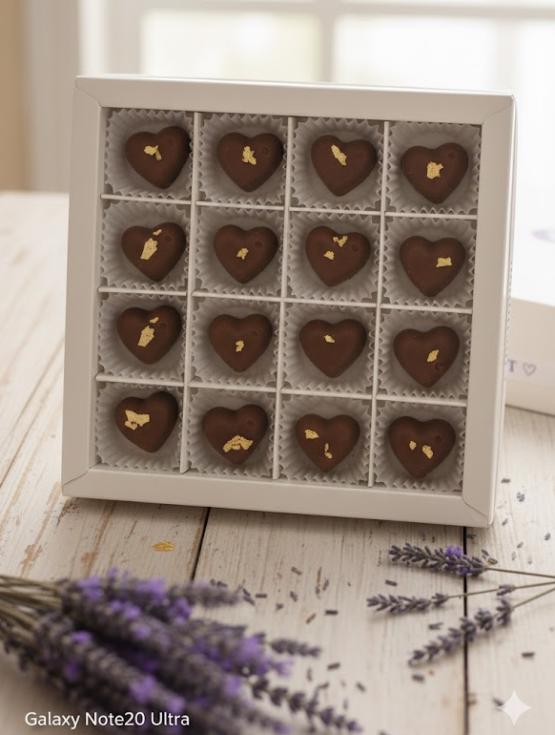
Description:
. It contains 32 pieces of rich, heart-shaped chocolate. Each piece is crafted with care and filled with various delicious gourmet fillings.

